Georgia State Parks and Historic Sites
Weekend Summary
05.18.2020

Crowds:
- Sites that temporarily limited day use access to ensure social distancing included: Black Rock, Cloudland Canyon, Don Carter, Florence Marina boat ramp, Fort McAllister boat ramp, Fort Yargo, James H. Floyd, Mistletoe, Providence, Red Top Mountain, Sweetwater Creek, Tallulah Gorge, Vogel, and Wormsloe. Other sites had high visitation including Franklin D. Roosevelt and High Falls.

- Golf Course activity: Golf continues to see high use and this week was 96% above the same week last year. Boat ramp activity: Florence Marina and Fort McAllister boat ramps reached capacity and limited access this weekend. George L. Smith reduced crowding at the ramp by installing directional signs for parking at the secondary boat ramp. The Bethany Bridge boat ramp at Red Top Mountain continues to experience high traffic and overflow parking but this is typical for the summer season.

Staffing issues:
- As of today, the Division as a whole has 74 part-time and full-time staff out due to COVID-19 related reasons. A total of 42 Camp Host Units (approximately 84 people) have left due to COVID-19 and 34 units have been replaced.

Positives
- The teamwork and successful execution of the modified operation plans is working well. Staff sharing continues to be appreciated and a necessity to maintain park operations. DNR LED and GSP presence and assistance with enforcing the Governor’s EO is helpful. High overnight occupancy and revenues are encouraging.

- Wormsloe resumed charging full admission at the Gate Cottage with protections in place. A.H. Stephens opened four new equestrian campsites that were reserved immediately.

- The eRanger video series continues to be very popular and this past week there were 513 website views, 890 YouTube views and 102,100 Facebook views. There have been 972,800 Facebook views since the launch on March 25th. Website activity continues to be high with total Pageviews up 166%- 2.1 mil views this week Reservations page views were up 118% and the Alerts Page had 26,059 views.

Challenges
- Maximum capacity at several sites continues to create additional staffing needs. At Tallulah Gorge, neighborhood parking with visitors walking into the gorge during restricted access periods is challenging.
- Staff shortages in the region are on-going, but staff sharing has helped.
- At Laura Walker, LED Game Wardens had to enforce crowd size and swimming in unauthorized areas.
- Game Wardens at General Coffee had to deal with multiple social distancing issues and playground usage. Drones were reported flying from Crooked River over the adjoining Kings Bay Submarine Base.
- At Fort King George visitors continue to avoid paying, ignoring signs and attempting to enter the museum, and discarding used PPE on the ground.
- Local metro parks are opening parks with limited access, but they have not opened their restroom facilities for visitors. Park Rangers at Sweetwater Creek and Red Top Mountain have received comments from guests that they will not return to local city or county parks until the restrooms are open.
- Sweetwater Creek visitors are parking along Mt. Vernon Rd. even when the gate is open. This leads us to believe some guests are parking on the road to get out of paying for a daily park pass. Foot traffic into the park is causing capacity and EO issues which has led to delays in opening the main gate back up. Visitors are moving traffic barrels and parking between them. Neighbors continue to call the park to complain about cars parking in their neighborhoods blocking mailboxes, fire hydrates, and driveways. Over 150 cars were parked along Mt. Vernon Rd on Saturday and Sunday. Douglas County Sheriff's Office called the site twice over the weekend to ask the assistant manager what he was going to do about the parking issue.
- Red Top Mountain visitors are parking along Red Top Rd. across from the beach entrance once access was limited. Barrels were moved by visitors and they walked to the beach. Social distancing became an issue on Saturday at the beach. On Sunday social distancing was improved by a better limited parking plan, but once visitors started moving barrels and parking along Red Top Rd. social distancing became an issue. The site does not have enough staff to cover all areas while trying to follow their operation plan to limit access.

Weekend Occupancy:
Past Weekend:
Our overall occupancy for all reservables increased 2% this past weekend to 78%. This is the third weekend in a row since COVID started that the overall weekend occupancy has increased. Cottage rentals continue to return, but are still less than previous years. This past weekend we were 11% less than last year, at a 79% occupancy rate. Camping continues to see high occupancy, reaching 88% this past weekend. This is up 6% from the same weekend last year. Yurt occupancy saw a 8% drop this past weekend, at 87%.
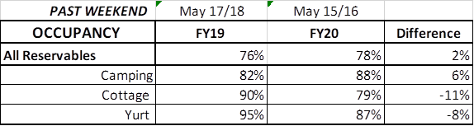

Upcoming Weekend:
For the upcoming weekend, we are seeing a 2% decrease in all reservables, similar to what we saw last week. Camping is showing a 1% increase over last year, up to 89% occupancy. Cottages are showing a 7% decrease compared to the same weekend last year. Last week at this point, we were showing an 18% decrease. For this upcoming weekend, yurts are already 97% booked. This is up 1% over last year.

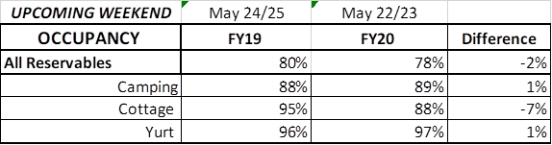

Revenue:
For the month of March through May 17th, we have seen a decrease in revenue of 7% or a loss of $586,000. This past week, May 11th – May 17th, we actually saw a 76% or $559,000 increase in overall revenue. This is the fifth week in a row our revenue has increased since the COVID situation began, and the third week our increase was over 45%.

ParkPass has now increased 5% or $50,000 during this timeframe. This past week, ParkPass revenue jumped 110% or $85,000.

For overnight accommodations – camping revenue has now increased 51%, over $1.4 Million since March. This past week it increased 185% or $392,000. This is the 5th week in a row camping revenue has more than doubled. Cottages also saw a significant increase this past week, and are now only at a 10% or $200,000 loss during this time period; yurts are now seeing a 17% increase over last year, or $27,000.

Golf continues to see a substantial improvement over last year, seeing a huge jump this past week of 96% or $36,000. During COVID, golf revenue has increased 16% or $78,000.

The revenue continues to significantly improve over last week due to several reasons:
- In early April we changed policy from collecting only a one-night deposit when booking a reservation, to collecting all revenue at the time of booking. This is the reason for the significant increase to camping and yurt revenue , and that cottage revenue is starting to rebound. This will have an effect on future revenue collections and the amount of refunds given.
- Camping occupancy has actually improved over the previous year for the 5th weekend in a row, with an occupancy increase of 7% last weekend.
- And again, the number of cancellations is starting to significantly slow down. Although we do need to keep in mind, that for future refunds, we will be refunding the revenue for the entire stay, rather than just a one-night deposit.

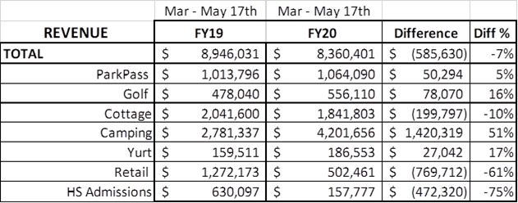

Cancellations/Refunds:
Through this morning, we have had 26,600 reservation cancellations, including $2.3 Million in actual refunds and a loss of future revenue of $9,300,000.
This is 2,150 more than last Monday, when we were at 24,450 cancellations. The significant drop in the number of cancellations continues, as initially we had 4,000 – 5,000 a week. Last year during the same week we had approximately 800 cancellations, thus we had 1,350 more cancellations this past week than last year during the same time period.
Last year during March thru YTD, we had 8,400 cancellations, including $412,000 in actual refunds and a loss of future revenue of $2.0 Million.
So, total cancellations have increased over 18,200 or 216% and the amount of refunds have increased $1.9 Million.

